# Home Assignment

Janne Flinck

79428

## Part 1

**#1** The proportion for mostly right-handed is about 0.899 and mostly left-handed is about 0.1.

**#2** Writing, Drawing, Throwing, Cutting scissors, Brushing teeth, Cutting.

**#3**

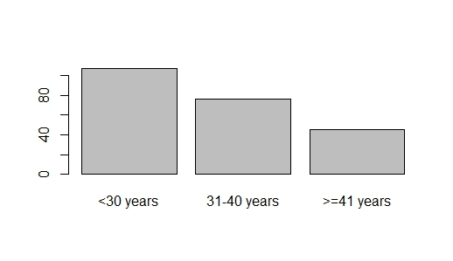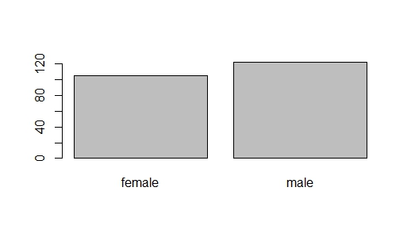

<30 years 31-40 years >=41 years female male

102 75 41 100 118

The proportion of males is about 54%. It is my understanding that in the general population the proportion is about 51%.

Cell Contents

|-------------------------|

| N |

| Chi-square contribution |

| N / Row Total |

| N / Col Total |

| N / Table Total |

|-------------------------|

Total Observations in Table: 218

| dat$Age

dat$Right | <30 years | 31-40 years | >=41 years | Row Total |

--------------------|-------------|-------------|-------------|-------------|

other | 9 | 8 | 6 | 23 |

| 0.288 | 0.001 | 0.648 | |

| 0.391 | 0.348 | 0.261 | 0.106 |

| 0.088 | 0.107 | 0.146 | |

| 0.041 | 0.037 | 0.028 | |

--------------------|-------------|-------------|-------------|-------------|

mostly right-handed | 93 | 67 | 35 | 195 |

| 0.034 | 0.000 | 0.076 | |

| 0.477 | 0.344 | 0.179 | 0.894 |

| 0.912 | 0.893 | 0.854 | |

| 0.427 | 0.307 | 0.161 | |

--------------------|-------------|-------------|-------------|-------------|

Column Total | 102 | 75 | 41 | 218 |

| 0.468 | 0.344 | 0.188 | |

--------------------|-------------|-------------|-------------|-------------|

| dat$Sex

dat$Right | female | male | Row Total |

--------------------|-----------|-----------|-----------|

other | 9 | 14 | 23 |

| 0.228 | 0.193 | |

| 0.391 | 0.609 | 0.106 |

| 0.090 | 0.119 | |

| 0.041 | 0.064 | |

--------------------|-----------|-----------|-----------|

mostly right-handed | 91 | 104 | 195 |

| 0.027 | 0.023 | |

| 0.467 | 0.533 | 0.894 |

| 0.910 | 0.881 | |

| 0.417 | 0.477 | |

--------------------|-----------|-----------|-----------|

Column Total | 100 | 118 | 218 |

| 0.459 | 0.541 | |

--------------------|-----------|-----------|-----------|

**#4**

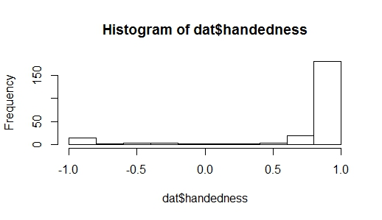

Mean: 0.76

Median: 1

Use median because of skewness.

**#5**

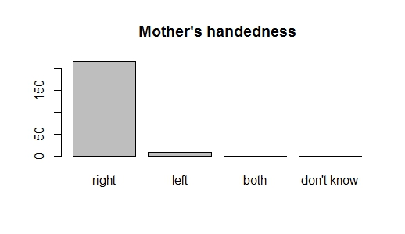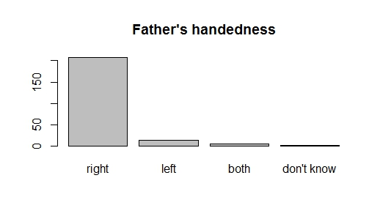

**#6**

Correlation: -0.0696

Not correlated.

## Part 2

**#1**

Call:

lm(formula = dat$handedness ~ dat$Mothershand + dat$Fathershand)

Residuals:

Min 1Q Median 3Q Max

-1.80849 0.07387 0.19151 0.19151 0.90725

Coefficients:

Estimate Std. Error t value Pr(>|t|)

(Intercept) 0.80849 0.03776 21.413 <2e-16 ***

dat$Mothershandleft -0.42743 0.17345 -2.464 0.0145 *

dat$Mothershandboth 0.19151 0.53317 0.359 0.7198

dat$Mothershanddon't know 0.14286 0.75213 0.190 0.8495

dat$Fathershandleft -0.28830 0.14801 -1.948 0.0527 .

dat$Fathershandboth -0.26563 0.24082 -1.103 0.2712

dat$Fathershanddon't know 0.04866 0.53317 0.091 0.9274

---

Signif. codes: 0 ‘***’ 0.001 ‘**’ 0.01 ‘*’ 0.05 ‘.’ 0.1 ‘ ’ 1

Residual standard error: 0.5318 on 220 degrees of freedom

(1 observation deleted due to missingness)

Multiple R-squared: 0.05381, Adjusted R-squared: 0.028

F-statistic: 2.085 on 6 and 220 DF, p-value: 0.05605

Intercept is y’s prediction when everything else is zero. If mothers hand is left then the predicted mean score is -0.42 lower than if it was right. If mothers hand is both then the mean score is 0.19 higher than right. If mothers hand is don’t know then the mean score goes up by 0.19 than if it were right. Same interpretations for fathers hand.

Call:

lm(formula = dat$handedness ~ dat$Mothershand + dat$Fathershand +

dat$Sex)

Residuals:

Min 1Q Median 3Q Max

-1.85657 0.03232 0.14343 0.22854 0.96872

Coefficients:

Estimate Std. Error t value Pr(>|t|)

(Intercept) 0.85657 0.05418 15.810 <2e-16 ***

dat$Mothershandleft -0.44951 0.17427 -2.579 0.0106 *

dat$Mothershandboth 0.22854 0.53411 0.428 0.6692

dat$Mothershanddon't know 0.05775 0.75541 0.076 0.9391

dat$Fathershandleft -0.29068 0.14800 -1.964 0.0508 .

dat$Fathershandboth -0.24562 0.24152 -1.017 0.3103

dat$Fathershanddon't know 0.08568 0.53411 0.160 0.8727

dat$Sexmale -0.08511 0.07197 -1.183 0.2383

---

Signif. codes: 0 ‘***’ 0.001 ‘**’ 0.01 ‘*’ 0.05 ‘.’ 0.1 ‘ ’ 1

Residual standard error: 0.5317 on 218 degrees of freedom

(2 observations deleted due to missingness)

Multiple R-squared: 0.06049, Adjusted R-squared: 0.03032

F-statistic: 2.005 on 7 and 218 DF, p-value: 0.05567

Everything else being constant, if the sex is male then the mean score is -0.085 lower than if the sex was female. Some change in the coefficients can be seen and the R-squared value improves a bit.

**#2**

Call:

lm(formula = dat$handedness ~ dat$Theory)

Residuals:

Min 1Q Median 3Q Max

-1.78529 0.09706 0.21471 0.24992 0.24992

Coefficients:

Estimate Std. Error t value Pr(>|t|)

(Intercept) 0.75008 0.05165 14.523 <2e-16 ***

dat$Theoryyes 0.03522 0.07149 0.493 0.623

---

Signif. codes: 0 ‘***’ 0.001 ‘**’ 0.01 ‘*’ 0.05 ‘.’ 0.1 ‘ ’ 1

Residual standard error: 0.5392 on 226 degrees of freedom

Multiple R-squared: 0.001073, Adjusted R-squared: -0.003347

F-statistic: 0.2427 on 1 and 226 DF, p-value: 0.6228

The intercept value of 0.75 means that the score is 0.75 if theory is no. If Theory is yes then the mean value of the score is 0.035 higher than if theory was no.

**#3**

Call:

lm(formula = dat$handedness ~ dat$Theory + dat$Skills)

Residuals:

Min 1Q Median 3Q Max

-1.7853 0.0921 0.2147 0.2171 0.2846

Coefficients:

Estimate Std. Error t value Pr(>|t|)

(Intercept) 0.71540 0.07416 9.647 <2e-16 ***

dat$Theoryyes 0.06990 0.08916 0.784 0.434

dat$Skillsyes 0.06750 0.10346 0.652 0.515

---

Signif. codes: 0 ‘***’ 0.001 ‘**’ 0.01 ‘*’ 0.05 ‘.’ 0.1 ‘ ’ 1

Residual standard error: 0.5399 on 225 degrees of freedom

Multiple R-squared: 0.002959, Adjusted R-squared: -0.005904

F-statistic: 0.3338 on 2 and 225 DF, p-value: 0.7165

Everything else being constant, if skill is yes then the mean score is 0.067 higher than if skill was no. Both have a high p-value and low coefficient estimates. Neither seems to be related to the score.

confint(logistic_model4)

Waiting for profiling to be done...

2.5 % 97.5 %

(Intercept) 1.2880540 3.018129

dat$Theoryyes -0.9773176 1.167055

dat$Skillsyes -1.1844280 1.267882

Confidence intervals of different parameters containing 0 imply that there is not a statistically significant difference between the classes.

**#4**

Call:

glm(formula = Right_handed ~ Mothershand + Fathershand, family = "binomial",

data = dat)

Deviance Residuals:

Min 1Q Median 3Q Max

-2.2191 0.4222 0.4222 0.4222 1.2751

Coefficients:

Estimate Std. Error z value Pr(>|z|)

(Intercept) 2.373e+00 2.578e-01 9.206 <2e-16 ***

Mothershandleft -1.376e+00 7.754e-01 -1.775 0.0759 .

Mothershandboth 1.419e+01 2.400e+03 0.006 0.9953

Mothershanddon't know 2.798e-11 3.393e+03 0.000 1.0000

Fathershandleft -1.224e+00 6.634e-01 -1.844 0.0651 .

Fathershandboth -9.867e-01 1.147e+00 -0.860 0.3898

Fathershanddon't know 1.419e+01 2.400e+03 0.006 0.9953

---

Signif. codes: 0 ‘***’ 0.001 ‘**’ 0.01 ‘*’ 0.05 ‘.’ 0.1 ‘ ’ 1

The logistic regression coefficients give the change in the log odds of the outcome for a one unit change in the predictor variable. For a change from Motherhandright to Motherhandleft, the log odds of being Right-handed(versus other) decreases by -1.38. For a change from Motherhandright to Motherhandboth, the log odds of being Right-handed(versus other) decreases by 1.419. To interpret the coefficients as odds ratios, you have to exponentiate them.

round(exp(coef(logistic_model1)[2]),3)

Mothershandleft

0.253

Now we can say that for a change from Motherhandright to Mothershandleft, the odds of being right-handed (versus other) is 25% less.

Call:

glm(formula = dat$Right_handed ~ dat$Mothershand + dat$Fathershand +

dat$Sex, family = "binomial")

Deviance Residuals:

Min 1Q Median 3Q Max

-2.3145 0.3772 0.4576 0.4576 1.3928

Coefficients:

Estimate Std. Error z value Pr(>|z|)

(Intercept) 2.6074 0.3899 6.688 2.27e-11 ***

dat$Mothershandleft -1.4656 0.7902 -1.855 0.0636 .

dat$Mothershandboth 14.3622 2399.5447 0.006 0.9952

dat$Mothershanddon't know -0.4035 3393.4687 0.000 0.9999

dat$Fathershandleft -1.2316 0.6682 -1.843 0.0653 .

dat$Fathershandboth -0.8906 1.1539 -0.772 0.4402

dat$Fathershanddon't know 14.3622 2399.5447 0.006 0.9952

dat$Sexmale -0.4035 0.4703 -0.858 0.3909

For a change from Sexfemale to Sexmale, the log odds of being Right-handed(versus other) decreases by -0.4.

Call:

glm(formula = dat$Right_handed ~ dat$Theory, family = "binomial")

Deviance Residuals:

Min 1Q Median 3Q Max

-2.1460 0.4590 0.4590 0.4854 0.4854

Coefficients:

Estimate Std. Error z value Pr(>|z|)

(Intercept) 2.0794 0.3062 6.792 1.11e-11 ***

dat$Theoryyes 0.1178 0.4413 0.267 0.79

---

Signif. codes: 0 ‘***’ 0.001 ‘**’ 0.01 ‘*’ 0.05 ‘.’ 0.1 ‘ ’ 1

For a change from Theoryno to Theoryyes, the log odds of being Right-handed(versus other) increases by 0.1178.

Call:

glm(formula = dat$Right_handed ~ dat$Theory + dat$Skills, family = "binomial")

Deviance Residuals:

Min 1Q Median 3Q Max

-2.1460 0.4590 0.4590 0.4807 0.4902

Coefficients:

Estimate Std. Error z value Pr(>|z|)

(Intercept) 2.05839 0.43352 4.748 2.05e-06 ***

dat$Theoryyes 0.13884 0.53752 0.258 0.796

dat$Skillsyes 0.04167 0.61237 0.068 0.946

---

Signif. codes: 0 ‘***’ 0.001 ‘**’ 0.01 ‘*’ 0.05 ‘.’ 0.1 ‘ ’ 1

For a change from Skillno to Skillyes, while holding Theory at a constant level, the log odds of being Right-handed(versus other) increases by 0.0417.

**#5**

Only 2 people in this sample have a left-handed mother and father, 1 of which is mostly left-handed.

The odds are 1.009217, so about 1% better.

**#6**

The data seems good for this purpose.